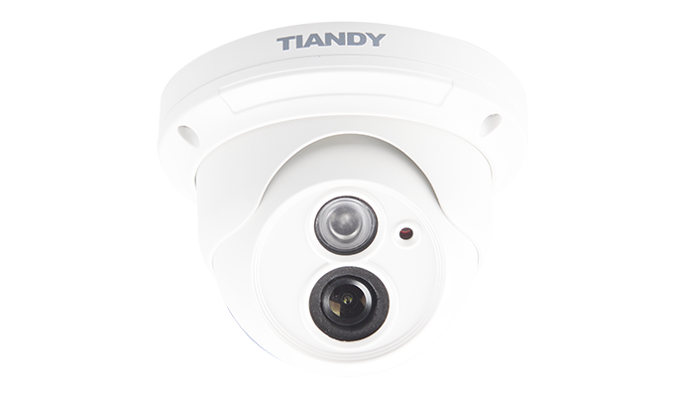

Features

• Ultra Low Light 0.002lux  
• Up to 1280×960 High Resolution  
• IR Range: 20-30m  
• NIR, WDR, 3D DNR, BLC,HLC, Dual-ICR  
• High Profile  
• Tripwire Detection  
• Perimeter Detection  
• TVS 6000V Protection, IP66, IK10

Specification

|  |  |
| --- | --- |
| Camera | |
| Image Sensor | 1/3″ Progressive Scan CMOS |
| Core Processor | ARM9 Architecture |
| Operating System | Embedded Linux |
| Signal System | PAL/NTSC |
| Min. Illumination | Color: 0.002Lux(F1.2,AGC ON) |
| B/W: 0.001Lux(F1.2,AGC ON)；0Lux with IR |
| Shutter Time | 1s～1/100000s |
| Lens | 2.8mm/4mm/6mm, Angle of View: 97°/78°/50° |
| Lens Mount | φ12 |
| Auto Iris | N/A |
| Day& Night | Dual IR Cut Filter with Auto Switch |
| Wide Dynamic Range | 100 dB |
| Digital Noise Reduction | 3D DNR |
| Compression Standard | |
| Video Compression | H.264/MJPEG |
| Encode Type | High Profile/Main Profile/Base Line Profile |
| Bit Rate | 32Kbps~16Mbps |
| Audio Compression | G.711/G.726/ADPCM |
| Bit Rate | 8K~48Kbps |
| Image | |
| Max. Image Resolution | 1280×960 |
| Frame Rate | 50Hz: 25fps (1280×960), 25fps (1280 × 720) |
| 60Hz: 30fps (1280×960), 30fps (1280 × 720) |
| Triple Stream | Mainstream:960P(1280×960) |
| Substream:D1(704×576) |
| 3rd stream:CIF(352×288) |
| Image Settings | Brightness, Saturation, Contrast,  Flip Mode Adjustable by Client Software or Web Browser |
| HLC | Y |
| Smart Defog | Y |
| Corridor | N/A |
| EIS | Y |
| ROI | 4 Zones |
| Privacy Mask | 4 Zones |
| Picture Overlay | 200 × 200, BMP 24bit, Zone Configurable |
| Network | |
| Browser | IE 7+, Chrome 18 +, Firefox 5.0 + |
| Mobile | P2P (IOS/Android) |
| Network Storage | NAS |
| Video Analytics | Tripwire/Perimeter(Available on 720P) |
| Alarm Trigger | Motion Detection/IP Conflict/MAC Conflict/Port Alarm |
| Protocols | TCP/IP/ICMP/HTTP/HTTPS/FTP/DHCP/DNS/DDNS/  RTP/RTSP/RTCP/PPPoE/NTP/UPnP/SMTP/SNMP/  IGMP/802.1X/QoS/IPv6/Bonjour |
| User Permission | 4 Level/8 Users |
| Remote Connection | 2-ch Access |
| NTP | Y |
| System Compatibility | ONVIF (Profile S),  SDK |
| Interface | |
| Audio Input | 1-ch |
| Audio Output | N/A |
| Communication Interface | 1-ch RJ45 10M / 100M Ethernet Interface |
| Alarm Input | N/A |
| Alarm Output | N/A |
| Video Output | N/A |
| On-board Storage | N/A |
| Extension | N/A |
| General | |
| Operating Conditions | -35℃～60℃(IR OFF) /-35℃～40℃(IR ON),  0～95% RHG |
| Power Supply | 12 VDC ± 10%, PoE (802.3af) |
| Power Consumption | Max. 3W(IR OFF) (ICR Instant Switch 7W) |
| Max. 5W(IR ON) |
| Circuit Protection | TVS 6000V, Lightning/  Surge Protection: (Power 2000V, RJ45 1000V) |
| Impact Protection | IP66, IK10 |
| IR Range | 20-30m |
| IR LEDs | 24pcs IR LEDs |
| Dimensions | 121mm×80mm×91mm |
| Weight | 600g (Camera Only); 800g (with Packing Box) |

Dimension

